Nature 2022 Dec; 612(7941):758-763.

doi: 10.1038/s41586-022-05542-y. Epub 2022 Dec 14.

Article

SARS-CoV-2 infection and persistence in the human body and brain at autopsy

尸检时SARS-CoV-2感染并持续存在于人体和脑部

收到日期：2021年12月3日

接受日期：2022年11月8日

在线发布：2022年12月14日

**摘要**

-------------------------------------------------------------------------------------------------------------

已知新冠肺炎-2019（COVID-19）在严重急性呼吸综合征新型冠状病毒2型（SARS-CoV-2）急性感染期间会导致多器官功能障碍(refs. 1-3)，一些患者出现长期症状，称为SARS-CoV 2急性后遗症。(refs. 4,5 )

然而，呼吸道外感染的负担和病毒清除的时间没有很好的特征，特别是在大脑(refs. 3、6–14)中。在这里，我们对44名死于新冠肺炎的患者进行了完整的尸检，对其中11名患者的中枢神经系统进行了广泛采样，以绘制和量化SARS-CoV-2在从急性感染到症状出现7个多月后在包括大脑在内的整个人体内的分布、复制和细胞类型特异性。

我们发现SARS-CoV-2广泛分布，主要在死于严重新冠肺炎的患者中，病毒复制存在于感染早期的多个呼吸道和非呼吸道组织中，包括大脑。此外，我们在多个解剖部位（包括整个大脑）检测到持续存在的SARS-CoV-2 RNA，最长时间在一例患者出现症状后230天。尽管SARS-CoV-2 RNA在全身广泛分布，但我们几乎没有观察到呼吸道外感染或直接病毒细胞病理学的证据。我们的数据表明，在某些患者中，SARS-CoV-2可导致全身感染，并在体内持续数月。

-------------------------------------------------------------------------------------------------------------

新冠肺炎有呼吸道和非呼吸道症状(refs. 1-3)，包括严重和致命疾病患者的多器官衰竭和休克。一些幸存的人经历SARS-CoV-2的急性后遗症，也称为长期COVID(refs. 4,5 )。尽管对致命新冠肺炎病例的尸检研究支持SARS-CoV-2感染多个器官的能力(refs.3,7–12)，但肺外器官通常缺乏病毒介导损伤或炎症的组织病理学证据(refs.10–14)。呼吸道外感染而无损伤或炎症的悖论引发了许多与病原体和宿主相关的问题。

为了研究人类SARS-CoV-2的细胞向性、复制能力、持续性和进化，并在感染组织中寻找相关组织病理学，我们对44例新冠肺炎病例进行了尸检。我们的方法侧重于及时、系统和全面的组织取样和保存，以进行补充分析。我们进行了微滴式数字PCR（ddPCR）检测和定量SARS-CoV-2核衣壳（N）基因靶点，并进行了原位杂交（ISH），以验证ddPCR结果并确定SARS-CoV-2的细胞趋向性。免疫荧光（IF）和生色免疫组化（IHC）用于进一步验证SARS-CoV-2在大脑中的存在。

我们采用逆转录定量实时PCR（RT–qPCR）检测亚基因组RNA，这是一种提示近期病毒复制的标记(refs. 15)，并通过在传统和改良的Vero E6细胞培养中分离病毒，证明了SARS-CoV-2在选定的呼吸和非呼吸组织（包括大脑）中具有复制能力。在6个个体中，我们使用高通量、单基因组扩增和测序（HT-SGS）测量了个体内SARS-CoV-2刺突基因变体的多样性和解剖分布。

我们将尸检病例分为早期（n = 17） ，中期（n = 13） 或晚期（n = 14） 死亡时的疾病日（d），分别为≤d14、d15–30或≥d31。我们将持续性定义为晚期病例中SARS-CoV-2 RNA的存在。我们分析并描述了呼吸和非呼吸组织的结果，以量化和统计比较组织和病例中SARS-CoV-2 RNA水平。

**Autopsy cohort overview**

**尸检队列概述**

-------------------------------------------------------------------------------------------------------------

在2020年4月26日至2021年3月2日期间，我们对死于新冠肺炎的未接种疫苗者进行了44次尸检。SARS-CoV-2 PCR阳性在42例患者死前被确认，2例患者死后被确认（P3和P17；Extended Data Fig. 1）。共有38例SARS-CoV-2血清阳性（补充数据1a），3例血清阴性（P27、P36和P37），3名患者（P3、P4和P15）血浆不可用。11例患者完成了脑部采样（Fig. 1）。

这一群体在种族和族裔上是多样的。30%为女性，中位年龄为62.5岁（四分位间距（IQR）：47.3–71.0；Extended Data Table 1a）。61.4%的患者有三种或三种以上的合并症。从症状发作到最终住院以及随后死亡的中位间隔为6 天（IQR:3-10）和18.5 天（IQR：11.25–37.5）（Extended Data Table 1b

）。中位死亡时间间隔为22.2 h（IQR:18.2–33.9）。个人级案例数据可在补充数据2a中找到。

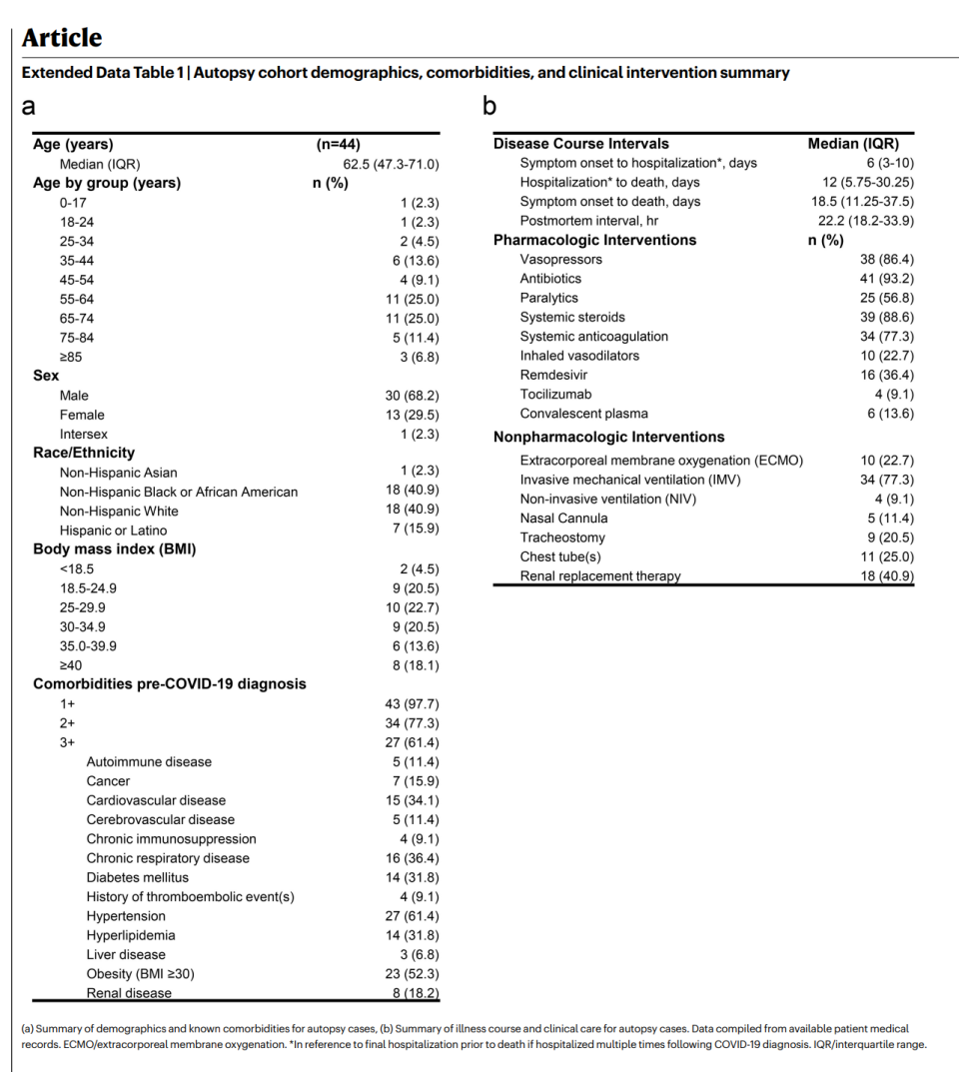

**Widespread infection and persistence**

**广泛感染和持续性**

-------------------------------------------------------------------------------------------------------------

在84个不同的解剖位置和体液中检测到SARS-CoV-2 RNA（补充数据1b–d），显著（P < 0.0001）早期（2.04 ± 0.10 log10[N基因拷贝数]每纳克RNA），mid（1.36 ± 每纳克RNA 0.12 log10[N基因拷贝数]）和晚期（0.67 ± 每纳克RNA 0.11log10[N基因拷贝数]；扩展数据图2a）案例。我们比较了疾病日SARS-CoV-2 RNA水平的线性趋势，作为一个连续变量，并观察到呼吸系统SARS-CoV-2 RNA水平（−3.14，s.e.0.39）与非呼吸系统（−1.62，s.e.0.38；P < 0.0001）组织（扩展数据图2 b，c）。

我们在11例早期和1例中期病例的死前血浆中检测到SARS-CoV-2 RNA（补充数据1b，d）。SARS-CoV-2 RNA在选择的早期和中期病例的外周血单核细胞中检测不到或略高于检测极限（补充数据1a）。每纳克RNA SARS-CoV-2 N基因拷贝的中位数和IQR以及在每个组织组和液体中检测到RNA的病例比例汇总在扩展数据表2中。

在所有晚期病例中，在多个组织组中检测到SARS-CoV-2 RNA持久性，尽管在血浆中没有检测到（补充数据1b–d）。在10/11例（90.9%）的中枢神经系统（CNS）组织中检测到SARS-CoV-2 RNA，包括5/6例晚期病例中评估的大多数大脑区域，包括死于D230的P42（Fig. 1）。

我们在所有组织组和多种液体类型（包括血浆、胸腔液和玻璃体液）中检测到SARS-CoV-2亚基因组RNA（补充数据1a–c）。在1025份联合检测样本中，ddPCR和亚基因组RNA RT-qPCR结果密切相关（ρ = 0.76; 95%置信区间（CI）：0.73–0.78），尤其是在呼吸样本中（n = 369, ρ = 0.86; 95%置信区间： 0.84–0.89）、早期病例（n = 496, ρ = 0.88; 95%置信区间： 0.85–0.89）和两种测定结果均为阳性的样品（n = 302, ρ = 0.91; 95%置信区间：0.88–0.93；扩展数据图2d，e）。在灵敏度和特异性加权相等的情况下，每纳克RNA≥1.47 N拷贝的ddPCR值预测亚基因组RNA阳性结果，敏感性为93.0%，特异性为91.6%，受试者操作特性（ROC）曲线下面积（AUC）为0.965（95%CI:0.953-0.977；扩展数据图2f）。

... ...

我们在Vero E6-TMPRS2-T2A-ACE2细胞16上再次尝试从丘脑和下丘脑分离P38的病毒，并观察到细胞病变效应48 接种P38的丘脑组织匀浆后h。在细胞病变效应发生时，对病毒分离过程的组织匀浆和上清液进行SARS-CoV-2包膜（E）基因组RNA的RT–qPCR，得到的Ct值分别为27.33和13.24。

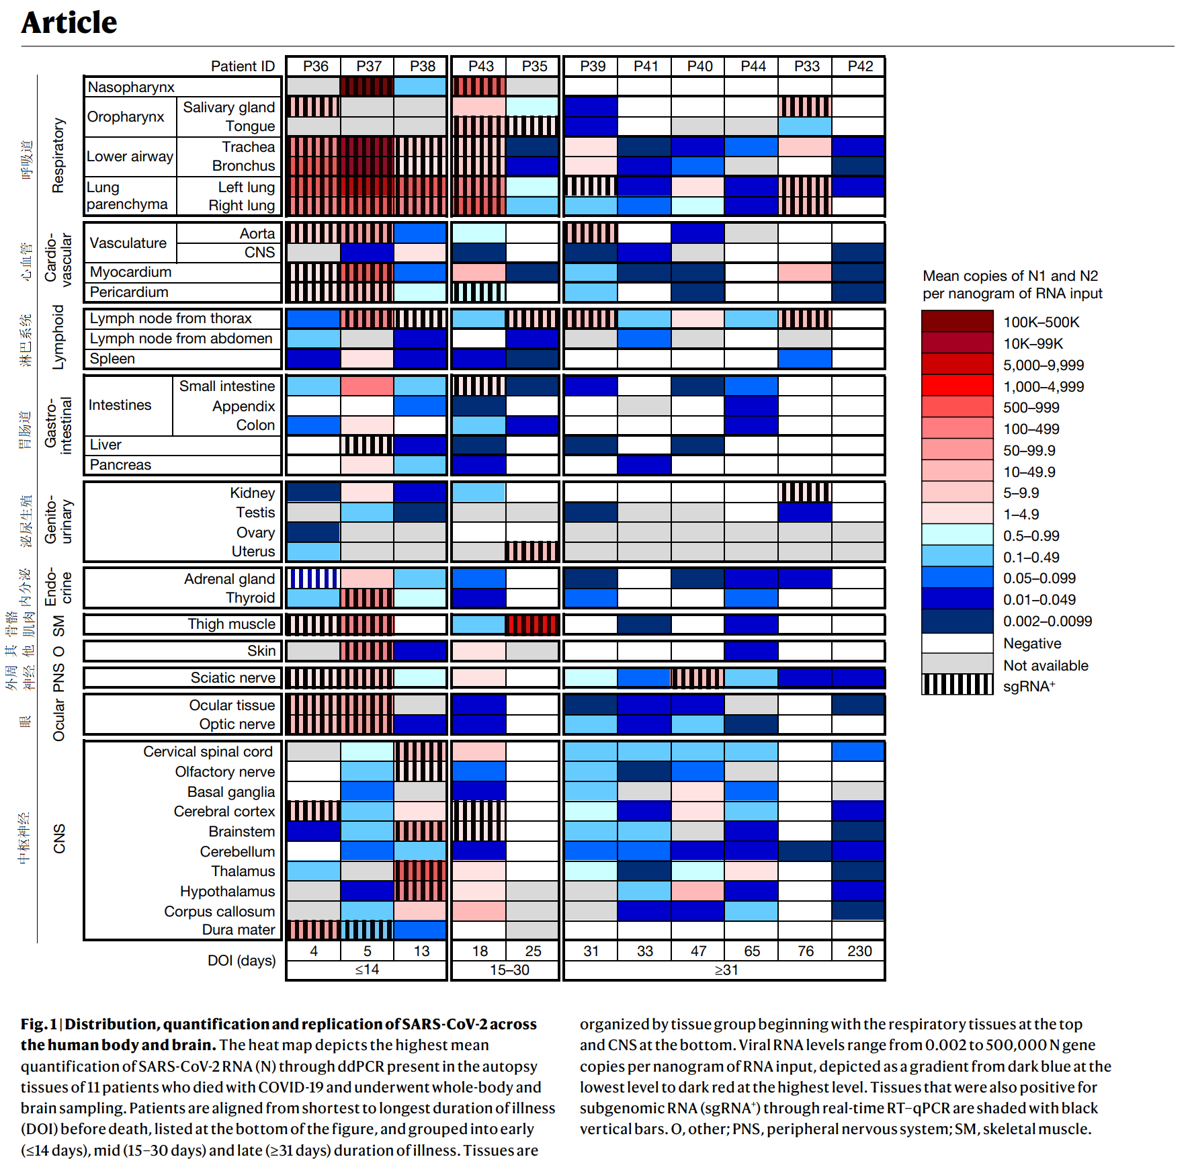

**Fig. 1**

SARS-CoV-2在人体和大脑中的分布、定量和复制

热图显示了11名死于新冠肺炎并接受全身和脑部取样的患者尸检组织中存在的通过ddPCR的SARS-CoV-2 RNA（N）的最高平均定量。患者在死亡前从最短到最长的患病时间（DOI）排列在图的底部，并分为早期（≤14天）、中期（15-30天）和晚期（≥31天）。

人体组织由组织群组构成，从顶部的呼吸道组织开始到底部的中枢神经系统。

病毒RNA水平范围为每纳克RNA输入0.002至500000 N基因拷贝，描绘为从最低水平的深蓝色到最高水平的深红色的梯度。通过实时RT–qPCR对亚基因组RNA（sgRNA+）也呈阳性的组织用黑色竖条表示。

O、 其他；PNS，外周神经系统；SM，骨骼肌。

**Fig. 1**

Distribution, quantification and replication of SARS-CoV-2 across the human body and brain. The heat map depicts the highest mean quantification of SARS-CoV-2 RNA (N) through ddPCR present in the autopsy tissues of 11 patients who died with COVID-19 and underwent whole-body and brain sampling. Patients are aligned from shortest to longest duration of illness (DOI) before death, listed at the bottom of the figure, and grouped into early (≤14 days), mid (15–30 days) and late (≥31 days) duration of illness.

Tissues are organized by tissue group beginning with the respiratory tissues at the top and CNS at the bottom.

Viral RNA levels range from 0.002 to 500,000 N gene copies per nanogram of RNA input, depicted as a gradient from dark blue at the lowest level to dark red at the highest level. Tissues that were also positive for subgenomic RNA (sgRNA+) through real-time RT–qPCR are shaded with black vertical bars.

O, other; PNS, peripheral nervous system; SM, skeletal muscle.

**Viral genome sequencing**

**病毒基因组测序**

-------------------------------------------------------------------------------------------------------------

我们使用HT-SGS分析了来自6个个体中总共46个组织的SARS-CoV-2刺突基因变体序列（Extended Data Fig.4）。在P27（D1）、P19（D7）和P18（D9）中，尽管单分子采样深度较高，但在呼吸和非呼吸部位未检测到非同义病毒遗传多样性。在P27中，两种病毒单倍型，每种都有一个同义替换，优先在包括右心室和左心室以及纵隔淋巴结在内的非呼吸道部位检测到。

在P38（D13）中，在31/31个肺序列和0/490个脑序列中鉴定出D80F残基，G1219V残基仅限于脑变体。SARS-CoV-2病毒通过Vero E6-TEMPRS2-TA2-ACE2细胞培养从P38的丘脑分离，并进行短读、全基因组测序，与从P38 RNA后期保存的丘脑检测到的次要单倍型和P38 RNA晚期保存的下丘脑的主要单倍型相匹配。P36（D4）硬脑膜中也检测到非同义替代，尽管采样深度很低（n = 2序列）。

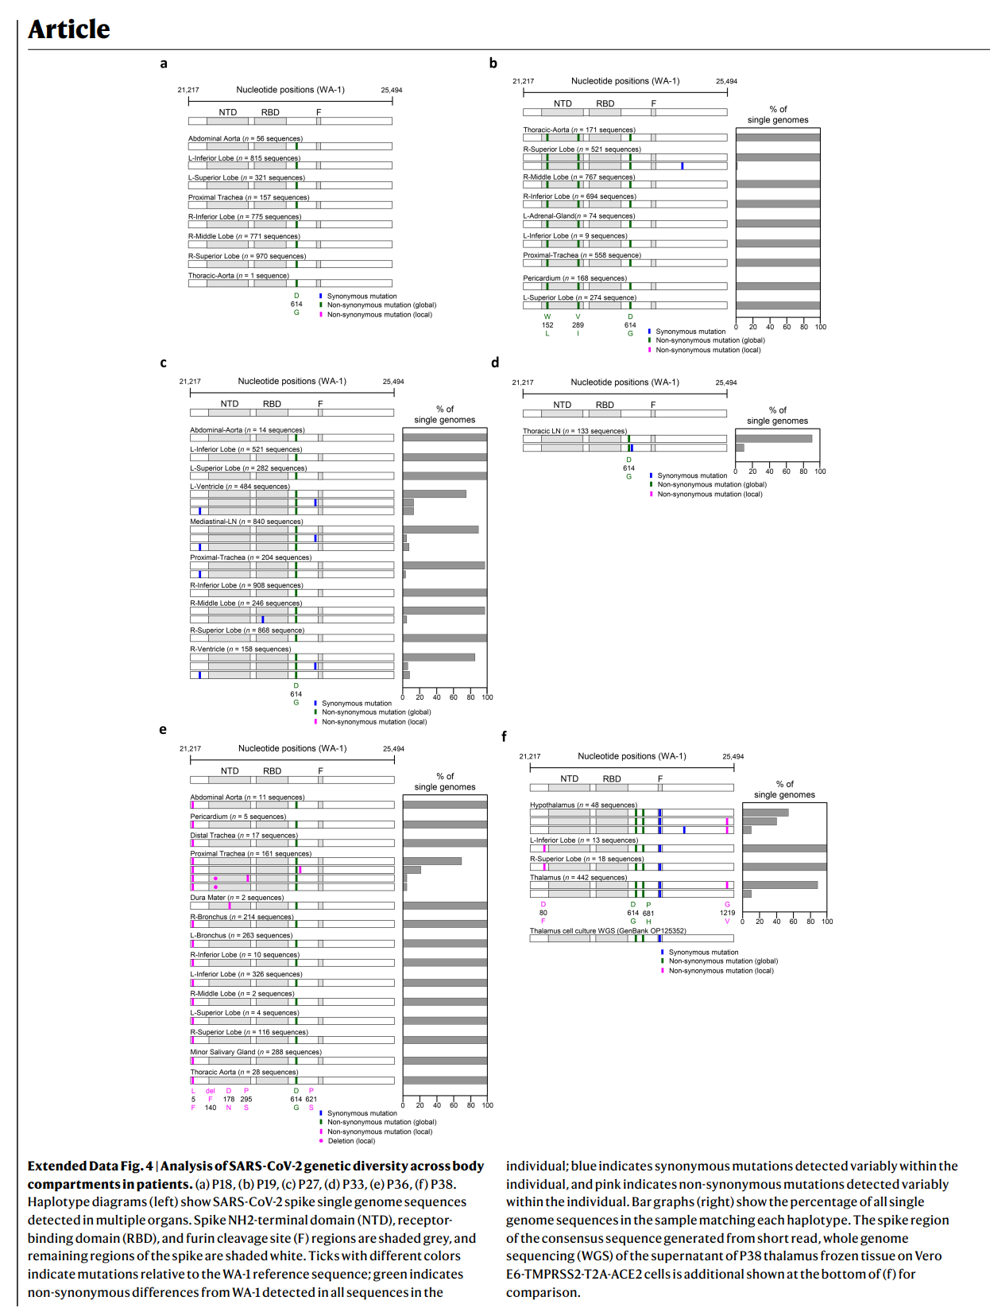

**ISH reveals the cellular tropism of SARS-CoV-2**

**ISH揭示SARS-CoV-2细胞（生物）向性**

-------------------------------------------------------------------------------------------------------------

我们通过ISH验证了我们对呼吸和非呼吸组织中SARS-CoV-2刺突RNA的ddPCR结果，该结果出现在35种以上细胞类型和透明膜的早期、中期和晚期病例中（Figs. 2 and 3，Extended Data Table 3 and Supplementary Data 3）。Figs. 2和Figs. 3以及Supplementary Data 3提供了SARS-CoV-2刺突RNA ISH阳性细胞的组织（包括跨多个大脑区域）的详细注释。

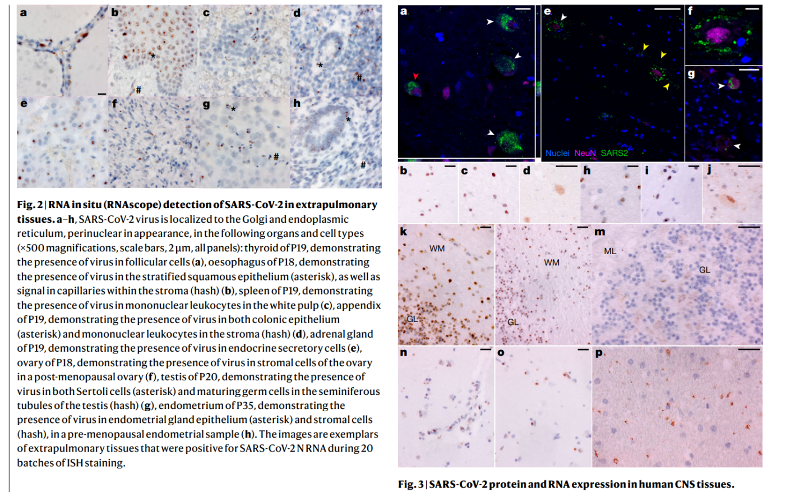

为了确定ddPCR检测到的SARS-CoV-2NRNA与ISH检测到的SAR S-CoV-2刺突RNA之间的关系，我们对16例病例的室间隔组织进行了图像分析，覆盖了每纳克RNA ddPCR值的4个对数范围的SARS-CoV-2N基因拷贝。由于组织形态学一致，选择了室间隔进行分析。平均SARS-CoV-2 N基因拷贝数/纳克RNA与30×40场SARS-CoV-2棘突RNA阳性细胞的中值显著相关（ρ = 0.704，95%置信区间：0.320–0.889，P = 0.002; Supplementary Data 3）。

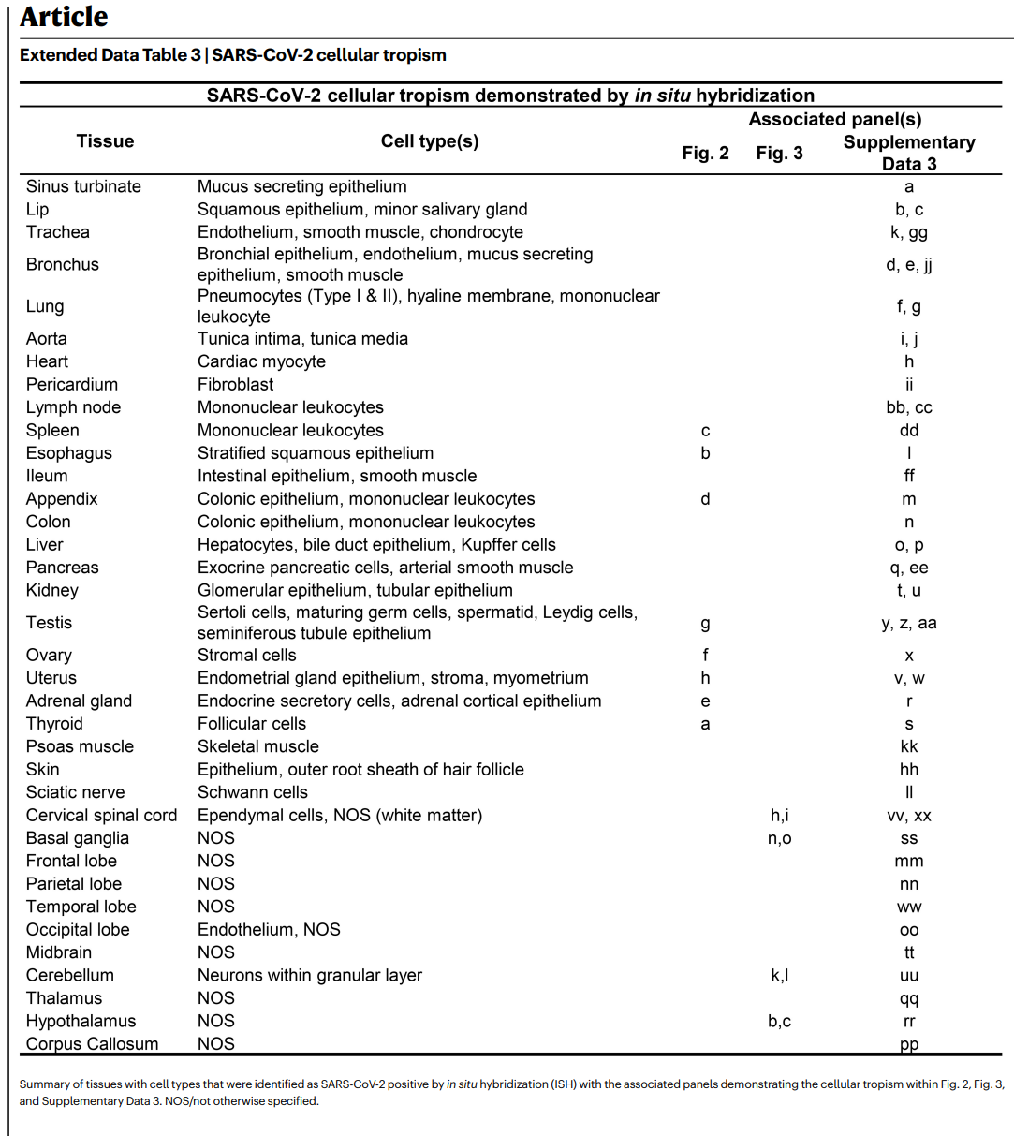

**SARS-CoV-2 N RNA and protein in CNS**

**中枢神经系统SARS-CoV-2 N RNA和蛋白**

-------------------------------------------------------------------------------------------------------------

为了进一步验证SARS-CoV-2在CNS组织中的检测和分布，我们使用了针对N RNA的第二次ISH测定，以及针对N蛋白的基于IF和显色IHC的测定。我们用适当的阳性和阴性对照（Supplementary Data 3，panels yy–bbb）确认了这些测定的特异性，并将其应用于通过ddPCR检测SARS-CoV-2阳性的选定CNS组织。我们在早期病例的下丘脑和小脑（P38）以及晚期病例的颈脊髓和基底节（分别为P42和P40）中观察到SARS-CoV-2 RNA和蛋白质，其模式与神经元染色一致（Fig. 3）。

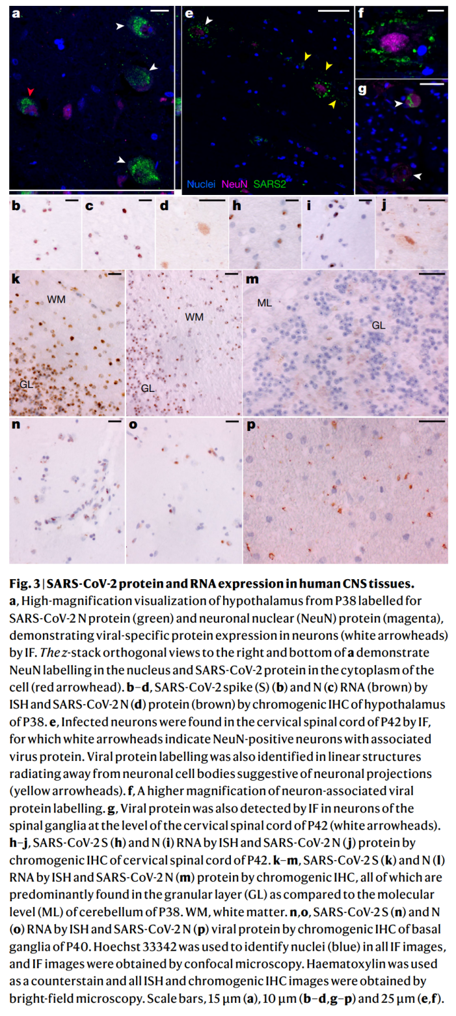

**COVID-19 histological findings**

**新冠肺炎的组织学表现**

-------------------------------------------------------------------------------------------------------------

我们队列中的组织病理学结果与其他病例系列中报告的结果相似（扩展数据图5）。在44例病例中，38例被确定死于新冠肺炎，其中35例（92.1%）在死亡时患有急性肺炎或弥漫性肺泡损伤（补充数据2）。弥漫性肺泡损伤的阶段显示出明显的时间进展（扩展数据图6）。10例（23%）患者出现了肺血栓栓塞并发症，4例患者出现了心肌浸润，其中1例为实质性心肌炎17（P3）。在淋巴结和脾脏中，我们观察到淋巴耗竭以及滤泡和皮质旁增生。

其他非呼吸道组织学改变主要与治疗并发症或已有的合并症有关。5例有陈旧性缺血心肌疤痕，3例有冠状动脉旁路移植。糖尿病肾病和脂肪性肝炎分别有10例（23%）和5例（12%）。一例已知丙型肝炎伴肝硬化，但其他晚期肝纤维化病例可能与脂肪肝疾病有关。肝脏坏死（13例，30%）和与急性肾损伤一致的变化（17例，39%）可能与这些重病患者的缺氧缺血性损伤有关。

在对11个大脑的检查中，我们发现了很少的组织病理学变化，尽管有大量的病毒负载。血管充血是一个不寻常的发现，其病因不明，可能与感染引起的血流动力学变化有关。在两个病例中发现了全局缺氧-缺血变化，其中一个是患有癫痫病的青少年（P36），入院时发现SARS-CoV-2阳性，但可能死于与病毒感染无关的癫痫并发症。

**Discussion**

**讨论**

-------------------------------------------------------------------------------------------------------------

据我们所知，在这里，我们提供了迄今为止最全面的SARS-CoV-2在人体（包括大脑）中的细胞取向、定量和持久性分析。我们专注于短的死后时间间隔、组织采集的全面标准化方法、固定前解剖大脑、在RNA中和新鲜组织的快速冷冻中保存组织，这使我们能够通过ddPCR和ISH以高灵敏度检测和定量SARS-CoV-2 RNA水平，并从包括大脑在内的多个非呼吸组织中分离细胞培养中的病毒，与其他研究相比有显著差异。

我们发现，SARS-CoV-2在一些患者感染早期传播，呼吸道组织中的病毒负荷明显高于非呼吸道组织。我们在症状出现后的头两周内证明了病毒在多个非呼吸道部位的复制，并在27例D14以外的病例中的14例中检测到至少一个组织中的亚基因组RNA，表明病毒复制可能在几个月内发生在非呼吸道组织中。

尽管其他人提出，非呼吸道组织中SARS-CoV-2的检测可能是由于组织内的残余血液(refs. 8,18)或组织采购过程中肺部的交叉污染(refs. 8)，但我们的数据表明并非如此。具体而言，我们的病例中只有12例在死前血浆样本中检测到SARS-CoV-2 RNA，只有2例在血浆中检测到了SARS-CoV-2亚基因组RNA，而在代表性病例的外周血单个核细胞中检测到的RNA（如果有的话）可以忽略不计。此外，我们通过ISH、IHC和IF对细胞中的病毒进行直接细胞鉴定，通过细胞培养分离SARS-CoV-2，并在非呼吸道部位检测不同的SARS-CoV-2刺突序列变体，从而验证了在呼吸道外检测SARS-CoV-1的有效性。

其他人先前报道了SARS-CoV-2 RNA在心脏、淋巴结、小肠和肾上腺中的表达(refs. 6,8–12,18)。我们复制了这些发现，并最终证明SARS-CoV-2能够在这些组织和包括大脑在内的许多其他组织中感染和复制。具体而言，我们报道了使用稳定表达ACE2和TMPRSS2的修饰Vero E6细胞系在D13从P38的丘脑中恢复复制能力SARS-CoV-2。这与通过PCR检测基因组RNA和亚基因组RNA、显示中枢神经系统细胞内SARS-CoV-2 RNA和蛋白质的多种成像模式以及通过中枢神经系统测序检测到的不同小变体一起，明确证明SARS-CoV-2能够在人脑内感染和复制。

SARS-CoV-2刺突的HT-SGS在许多组织中显示出同种病毒群体，同时在其他组织中也显示出信息性病毒变体。SARS-CoV-2序列的个体内低多样性在先前的研究(refs. 19–21)中经常被观察到，这可能与病毒的固有突变率以及缺乏驱动病毒进化的早期免疫压力有关。值得注意的是，我们的HT-SGS方法对每个样本中的微小变异都具有高准确度和高灵敏度，使得低病毒多样性的发现高度可靠(refs. 22)。

SARS-CoV-2在几个个体的呼吸和非呼吸组织之间的遗传区隔支持病毒在这些位点的独立复制，尽管位点之间缺乏区隔并不排除病毒的独立复制。我们注意到几个案例，其中脑源性病毒刺突序列相对于其他非中枢神经系统组织的序列显示出非同义变化。需要进一步研究，以了解这些病例是否可能代表中枢神经系统的随机接种或中枢神经系统中抗病毒抗体对刺突的不同选择性压力，如其他人所建议的(refs. 23–25)。

我们的结果表明，尽管SARS-CoV-2的最高负担是在呼吸道组织中，但病毒可以在全身传播。尽管其他人认为，这种病毒传播通过细胞贩运11发生，原因是据报道未能从血液中培养SARS-CoV-2 (refs. 3,26)，但我们的数据支持早期病毒血症阶段，该阶段在呼吸道感染后将病毒传播到全身。最近的研究(refs. 26)从急性新冠肺炎患者的血浆中造粒SARS-CoV-2病毒并成像，支持这种病毒传播机制。我们的队列主要由严重和最终致命的新冠肺炎病例组成。然而，有两例患者（P36和P42）仅报告有轻微或无呼吸道症状，死因不是死于COVID-19，但SARS-CoV-2 RNA在全身和大脑广泛检测到。此外，P36是一名有潜在神经系统疾病的青少年，但没有儿童多系统炎症综合征的证据，这表明儿童可能会出现SARS-CoV-2全身感染，而不会出现全身炎症反应。

最后，我们的工作开始阐明SARS-CoV-2 RNA能够持续的时间和位置。尽管呼吸道是SARS-CoV-2 RNA持续存在的最常见部位，但≥50%的晚期病例在心肌、头颈部淋巴结、胸部淋巴结、坐骨神经、眼组织以及中枢神经系统所有采样区域（硬脑膜除外）中也存在持续RNA。

值得注意的是，尽管在早期病例中呼吸道组织中SARS-CoV-2 RNA比非呼吸道组织高100倍以上，但在晚期病例中，这种差异大大减少。非呼吸道组织中病毒清除效率较低可能与SARS-CoV-2改变病毒mRNA的细胞检测、干扰干扰素信号或破坏病毒抗原处理和表达能力的组织特异性差异有关(refs. 27–29)。了解SARS-CoV-2逃避免疫检测的机制对于指导未来促进病毒清除的治疗方法至关重要。

我们在超过60%队列的组织中检测到亚基因组RNA，包括D99病例的多个组织。尽管亚基因组RNA是在病毒活跃复制过程中产生的，但在证明具有复制能力的病毒方面，它不如细胞培养物明确，因为亚基因组RNA受到双膜囊泡的保护，这种囊泡有助于核酸酶抗性和寿命，超过病毒立即复制(refs. 30–33)。

然而，通过多种粘膜途径暴露于γ辐射SARS-CoV-2接种物（亚基因组RNA拷贝数高）的非人灵长类动物在接种后第1天的呼吸道样本中检测到SARS-CoV 2基因组RNA，但检测不到亚基因组RNA水平(refs. 15)。这些数据表明SARS-CoV-2亚基因组RNA的检测可能反映了最近的病毒复制。然而，在我们的病例子集中，亚基因组RNA的长期检测可能代表病毒复制的缺陷，而非生产性，这在亚急性硬化性全脑炎病例中被描述为持续感染麻疹病毒，另一种单链包膜RNA病毒(refs. 34)。

我们的研究有几个重要的局限性。首先，我们的队列主要代表了因严重新冠肺炎而死亡的未接种疫苗的老年人，这限制了我们将研究结果外推到年轻、健康或接种疫苗的个人的能力。

其次，我们的病例发生在大流行的第一年，在变异毒株广泛传播之前，因此研究结果可能无法推广到当前和未来的SARS-CoV-2变种。

最后，尽管很容易将SARS-CoV-2急性后遗症的临床发现归因于病毒的持续存在，但我们的研究并不是为了解决这个问题。尽管存在这些局限性，但我们的发现从根本上改善了对SARS-CoV-2细胞在人体和大脑中分布和持久性的理解，并为未来开展类似研究提供了有力的理论基础，以确定SARS-CoV 2持久性的机制和SARS-CoV2急性后遗症的原因。

-------------------------------------------------------------------------------------------------------------

COVID-19 has respiratory and non-respiratory manifestations1–3, including multi-organ failure and shock among patients with severe and fatal disease. Some individuals who survive experience post-acute sequelae of SARS-CoV-2, also known as long COVID(4,5).

Although autopsy studies of fatal COVID-19 cases support the ability of SARS-CoV-2 to infect multiple organs(3,7–12), extrapulmonary organs often lack histopathological evidence of virally mediated injury or inflammation(10–14). The paradox of infection outside the respiratory tract without injury or inflammation raises many pathogen- and host-related questions.

To investigate the cellular tropism, replication competence, persistence and evolution of SARS-CoV-2 in humans, and to look for associated histopathology in infected tissues, we carried out autopsies on 44 COVID-19 cases. Our approach focused on timely, systematic and comprehensive tissue sampling and preservation for complementary analyses. We carried out droplet digital polymerase chain reaction (ddPCR) for detection and quantification of SARS-CoV-2 nucleocapsid (N) gene targets and in situ hybridization (ISH) to validate the ddPCR findings and determine the cellular tropism of SARS-CoV-2. Immuno-fluorescence (IF) and chromogenic immunohistochemistry (IHC) were used to further validate the presence of SARS-CoV-2 in the brain.

We carried out quantitative real-time PCR with reverse transcription (RT–qPCR) to detect subgenomic RNA, a marker suggestive of recent virus replication15, and demonstrated replication-competent SARS-CoV-2 in selected respiratory and non-respiratory tissues, including the brain, by virus isolation in traditional and modified Vero E6 cell culture. In six individuals, we measured the diversity and anatomic distribution of intra-individual SARS-CoV-2 spike gene variants using high-throughput, single-genome amplification and sequencing (HT-SGS).

We categorized autopsy cases as early (n = 17), mid (n = 13) or late (n = 14) by illness day (d) at the time of death, being ≤d14, d15–30 or ≥d31, respectively. We defined persistence as the presence of SARS-CoV-2 RNA among late cases. We analysed and described our results in terms of respiratory and non-respiratory tissues to quantify and statistically compare SARS-CoV-2 RNA levels across tissues and cases.

Autopsy cohort overview

-------------------------------------------------------------------------------------------------------------

... ...

Widespread infection and persistence

-------------------------------------------------------------------------------------------------------------

SARS-CoV-2 RNA was detected in 84 distinct anatomical locations and body fluids (Supplementary Data 1b–d), with a significantly (P < 0.0001 for all) higher burden detected in respiratory compared with non-respiratory tissues among early (2.04 ± 0.10 log10[N gene copies] per nanogram of RNA), mid (1.36 ± 0.12 log10[N gene copies] per nanogram of RNA) and late (0.67 ± 0.11 log10[N gene copies] per nanogram of RNA; Extended Data Fig. 2a) cases. We compared linear trends in SARS-CoV-2 RNA levels by illness day, as a continuous variable, and observed a significantly steeper negative slope of SARS-CoV-2 RNA levels in respiratory (−3.14, s.e. 0.39) compared with non-respiratory (−1.62, s.e. 0.38; P < 0.0001) tissues (Extended Data Fig. 2 b,c).

We detected SARS-CoV-2 RNA in perimortem plasma of 11 early and 1 mid case (Supplementary Data 1 b,d). SARS-CoV-2 RNA was undetectable or just above the limit of detection in peripheral blood mononuclear cells from select early and mid cases (Supplementary Data 1 a). The median and IQR of SARS-CoV-2 N gene copies per nanogram of RNA and proportion of cases with RNA detected in each tissue group and fluids are summarized in Extended Data Table 2.

SARS-CoV-2 RNA persistence was detected across multiple tissue groups among all late cases despite being undetectable in plasma in any (Supplementary Data 1b–d). SARS-CoV-2 RNA was detected in central nervous system (CNS) tissue in 10/11 cases (90.9%), including across most brain regions evaluated in 5/6 late cases, including P42 who died at D230 (Fig. 1).

Viral genome sequencing

-------------------------------------------------------------------------------------------------------------

... ...

ISH reveals the cellular tropism of SARS-CoV-2

-------------------------------------------------------------------------------------------------------------

We validated our ddPCR results by ISH for SARS-CoV-2 spike RNA in respiratory and non-respiratory tissues in selected early, mid and late cases across >35 cell types and hyaline membranes (Figs. 2 and 3, Extended Data Table 3 and Supplementary Data 3). Detailed annotation of SARS-CoV-2 spike RNA ISH-positive cells by tissue, including across multiple brain regions, is provided in Figs. 2 and 3 and Supplementary Data 3.

To determine the relationship between SARS-CoV-2 N RNA detected by ddPCR and SARS-CoV-2 spike RNA detected by ISH, we carried out image analysis on interventricular septal tissue from 16 cases covering a four-log range of SARS-CoV-2 N gene copies per nanogram of RNA ddPCR values. Interventricular septum was selected for this analysis owing to consistent histomorphology. Mean SARS-CoV-2 N gene copies per nanogram of RNA significantly correlated with the median SARS-CoV-2 spike RNA-positive cells over thirty ×40 fields (ρ = 0.704, 95% CI: 0.320–0.889, P = 0.002; Supplementary Data 3).

SARS-CoV-2 N RNA and protein in CNS

-------------------------------------------------------------------------------------------------------------

To further validate detection and distribution of SARS-CoV-2 in CNS tissue, we used a second ISH assay targeting N RNA, and IF and chromogenic IHC-based assays targeting N protein. We confirmed the specificity of these assays with appropriate positive and negative controls (Supplementary Data 3, panels yy–bbb) and applied them to selected CNS tissues that were SARS-CoV-2 positive by ddPCR. We observed SARS-CoV-2 RNA and protein in hypothalamus and cerebellum of an early case (P38) and cervical spinal cord and basal ganglia of late cases (P42 and P40, respectively), with a pattern consistent with neuronal staining (Fig. 3).

COVID-19 histological findings

-------------------------------------------------------------------------------------------------------------

The histopathology findings from our cohort were similar to those reported in other case series (Extended Data Fig. 5). Of 44 cases, 38 were determined to have died from COVID-19, and of these, 35 (92.1%) had either acute pneumonia or diffuse alveolar damage at the time of death (Supplementary Data 2). Phases of diffuse alveolar damage showed a clear temporal progression (Extended Data Fig. 6). Pulmonary thromboembolic complications were noted in 10 (23%) cases and myocardial infiltrates were observed in four cases, including one case of substantial myocarditis17 (P3). In the lymph nodes and spleen, we observed both lymphodepletion and follicular and paracortical hyperplasia.

Other non-respiratory histological changes were mainly related to complications of therapy or pre-existing comorbidities. Five cases had old ischaemic myocardial scars and three had coronary artery bypass grafts in place. Diabetic nephropathy and steatohepatitis were observed in ten cases (23%) and five cases (12%), respectively. One case had known hepatitis C with cirrhosis, but the other cases of advanced hepatic fibrosis were probably related to fatty liver disease. Hepatic necrosis (13 cases, 30%) and changes consistent with acute kidney injury (17 cases, 39%) were probably related to hypoxic–ischaemic injury in these very ill patients.

In the examination of 11 brains, we found few histopathologic changes, despite substantial viral burden. Vascular congestion was an unusual finding that had an unclear aetiology and could be relatedt to the haemodynamic changes incurred with infection. Global hypoxic–ischaemic change was seen in two cases, one of which was a juvenile (P36) with a seizure disorder who was found to be SARS-CoV-2 positive on hospital admission, but who probably died of seizure complications unrelated to viral infection.

Discussion

-------------------------------------------------------------------------------------------------------------

Here we provide, to our knowledge, the most comprehensive analysis to date of the cellular tropism, quantification and persistence of SARS-CoV-2 across the human body including the brain. Our focus on short postmortem intervals, a comprehensive standardized approach to tissue collection, dissecting the brain before fixation, preserving tissue in RNAlater and flash freezing of fresh tissue allowed us to detect and quantify SARS-CoV-2 RNA levels with high sensitivity by ddPCR and ISH, as well as isolate virus in cell culture from multiple non-respiratory tissues including the brain, which are notable differences compared to other studies.

We show that SARS-CoV-2 disseminates early in infection in some patients, with a significantly higher viral burden in respiratory than non-respiratory tissues. We demonstrated virus replication in multiple non-respiratory sites during the first two weeks following symptom onset and detected subgenomic RNA in at least one tissue in 14 of 27 cases beyond D14, indicating that viral replication may occur in non-respiratory tissues for several months.

Whereas others have proposed that the detection of SARS-CoV-2 in non-respiratory tissues might be due to residual blood within tissues(8,18) or cross-contamination from the lungs during tissue procurement(8), our data indicate otherwise.

Specifically, only 12 of our cases had detectable SARS-CoV-2 RNA in a perimortem plasma sample, only 2 cases had SARS-CoV-2 subgenomic RNA detected in plasma, and negligible, if any, RNA was detected in banked peripheral blood mononuclear cells from representative cases.

Further, we validated detection of SARS-CoV-2 outside the respiratory tract by direct cellular identification of virus in cells through ISH, IHC and IF, isolation of SARS-CoV-2 by cell culture, and detection of distinct SARS-CoV-2 spike sequence variants in non-respiratory sites.

Others have previously reported SARS-CoV-2 RNA within the heart, lymph node, small intestine and adrenal gland(6,8–12,18). We replicate these findings and conclusively demonstrate that SARS-CoV-2 is capable of infecting and replicating within these and many other tissues, including brain. Specifically, we report the recovery of replication-competent SARS-CoV-2 from thalamus of P38 at D13 using a modified Vero E6 cell line that stably expresses ACE2 and TMPRSS2. This along with detection of genomic RNA and subgenomic RNA through PCR, multiple imaging modalities showing SARS-CoV-2 RNA and protein within cells of the CNS, and distinct minor variants detected through sequencing in the CNS prove definitively that SARS-CoV-2 is capable of infecting and replicating within the human brain.

HT-SGS of SARS-CoV-2 spike demonstrates homogeneous virus populations in many tissues, while also revealing informative virus variants in others. Low intra-individual diversity of SARS-CoV-2 sequences has been observed frequently in previous studies19–21, and probably relates to the intrinsic mutation rate of the virus as well as lack of early immune pressure to drive virus evolution. It is important to note that our HT-SGS approach has both a high accuracy and a high sensitivity for minor variants within each sample, making findings of low virus diversity highly reliable22.

Genetic compartmentalization of SARS-CoV-2 between respiratory and non-respiratory tissues in several individuals supports independent replication of the virus at these sites, although lack of compartmentalization between sites does not rule out independent virus replication. We note several cases in which brain-derived virus spike sequences showed nonsynonymous changes relative to sequences from other non-CNS tissues. Further studies will be needed to understand whether these cases might represent stochastic seeding of the CNS or differential selective pressure on spike by antiviral antibodies in the CNS, as others have suggested23–25.

Our results show that although the highest burden of SARS-CoV-2 is in respiratory tissues, the virus can disseminate throughout the entireb body. Whereas others have posited that this viral dissemination occurs through cell trafficking11 due to a reported failure to culture SARS-CoV-2 from blood3,26, our data support an early viraemic phase, which seeds the virus throughout the body following infection of the respiratory tract. Recent work26 in which SARS-CoV-2 virions were pelleted and imaged from plasma of patients with acute COVID-19 supports this mechanism of viral dissemination. Our cohort is predominantly composed of severe and ultimately fatal COVID-19 cases. However, two cases (P36 and P42) reported only mild or no respiratory symptoms and died with, not from, COVID-19, yet had SARS-CoV-2 RNA widely detected across the body and brain. Additionally, P36 was a juvenile with an underlying neurological condition, but without evidence of multisystem inflammatory syndrome in children, suggesting that children may develop systemic infection with SARS-CoV-2 without developing a generalized inflammatory response.

Finally, our work begins to elucidate the duration and locations at which SARS-CoV-2 RNA can persist. Although the respiratory tract was the most common location in which SARS-CoV-2 RNA persisted, ≥50% of late cases also had persistent RNA in the myocardium, lymph nodes from the head and neck and from the thorax, sciatic nerve, ocular tissue, and in all sampled regions of the CNS, except the dura mater.

Notably, despite having more than 100 times higher SARS-CoV-2 RNA in respiratory compared to non-respiratory tissues in early cases, this difference greatly diminished in late cases. Less efficient viral clearance in non-respiratory tissues may be related to tissue-specific differences in the ability of SARS-CoV-2 to alter cellular detection of viral mRNA, interfere with interferon signalling, or disrupt viral antigen processing and presentation27–29. Understanding mechanisms by which SARS-CoV-2 evades immune detection is essential to guide future therapeutic approaches to facilitate viral clearance.

We detected subgenomic RNA in tissue from more than 60% of the cohort, including in multiple tissues of a case at D99. Although subgenomic RNA is generated during active viral replication, it is lessd definitive than cell culture at demonstrating replication-competent virus because subgenomic RNA is protected by double-membrane vesicles that contribute to nuclease resistance and longevity beyond immediate viral replication30–33.

However, nonhuman primates exposed to γ-irradiated SARS-CoV-2 inoculum with high subgenomic RNA copy numbers through multiple mucosal routes had detectable SARS-CoV-2 genomic RNA but undetectable subgenomic RNA levels in respiratory samples by day 1 post-inoculation15. These data suggest that detection of SARS-CoV-2 subgenomic RNA probably reflects recent viral replication. Prolonged detection of subgenomic RNA in a subset of our cases may, however, represent defective rather than productive viral replication, which has been described in persistent infection with measles virus—another single-strand enveloped RNA virus—in cases of subacute sclerosing panencephalitis34.

Our study has several important limitations. First, our cohort largely represents older unvaccinated individuals with pre-existing medical conditions who died from severe COVID-19, limiting our ability to extrapolate findings to younger, healthier or vaccinated individuals.

Second, our cases occurred during the first year of the pandemic, before widespread circulation of variants of concern, and thus findings might not be generalizable to current and future SARS-CoV-2 variants.

Finally, although it is tempting to attribute clinical findings observed in post-acute sequelae of SARS-CoV-2 to viral persistence, our study was not designed to address this question. Despite these limitations, our findings fundamentally improve the understanding of SARS-CoV-2 cellular distribution and persistence in the human body and brain and provide a strong rationale for pursuing future similar studies to define mechanisms of SARS-CoV-2 persistence and contribution to post-acute sequelae of SARS-CoV-2.

**作者背景:**

1. 美国马里兰州贝塞斯达国家卫生研究院，新兴病原体部，重症医学科，临床中心。
2. 美国马里兰州贝塞斯达国家卫生研究院国家过敏和传染病研究所免疫调节实验室。
3. 美国马里兰州贝塞斯达国家卫生研究院临床中心重症医学部。
4. 美国马里兰州贝塞斯达国家卫生研究院糖尿病、消化和肾脏疾病国家研究所肾脏疾病科。
5. 美国马里兰州贝塞斯达国家卫生研究院国家癌症研究所癌症研究中心病理学实验室。
6. 美国国家卫生研究所变态反应和传染病研究所室内研究部病毒学实验室，汉密尔顿。
7. 美国国家过敏症和传染病研究所落矶山实验室持续性病毒性疾病实验室，美国马萨诸塞州汉密尔顿国家卫生研究所。
8. 美国马里兰州贝塞斯达国家卫生研究院国家过敏和传染病研究所疫苗研究中心。
9. 美国马里兰州贝塞斯达国家卫生研究院牙科和颅面研究所。
10. 美国马里兰州巴尔的摩马里兰大学医学院。
11. 美国马里兰州贝塞斯达国立卫生研究院国家普通医学研究所博士后研究助理培训计划。
12. R Adams Cowley休克创伤中心，美国马里兰州巴尔的摩马里兰大学医学院创伤医学系。
13. R Adams Cowley休克创伤中心，美国马里兰州巴尔的摩马里兰大学医学院创伤外科和项目部。
14. 美国马里兰州巴尔的摩马里兰大学医学院传染病科医学部。
15. 美国马里兰州巴尔的摩马里兰大学医学院人类病毒学研究所。
16. 美国马里兰州巴尔的摩马里兰大学医学院心脏外科外科。
17. 美国马里兰州巴尔的摩马里兰大学医学院，内科，肺科和重症监护医学。
18. 美国马里兰州索尔兹伯里TidalHealth Peninsula Regional住院部。
19. 马里兰州大学圣约瑟夫医学中心医学院重症医学部，美国医学博士托森。
20. 美国马里兰州贝塞斯达国家卫生研究院变态反应和传染病研究所传染病实验室医学病毒学科。

这项研究由国家卫生研究院、临床中心、国家癌症研究所癌症研究中心、国家牙科和颅面研究所以及国家过敏和传染病研究所的校内研究计划资助和支持。这项研究是通过美国国立卫生研究院（NIH）医学研究学者计划实现的，这是一个由NIH共同支持的公私合作伙伴关系，Doris Duke慈善基金会、Genentech、美国牙科研究协会和高露洁棕榄公司对NIH基金会的捐款。

1Emerging Pathogens Section, Critical Care Medicine Department, Clinical Center, National Institutes of Health, Bethesda, MD, USA.

2Laboratory of Immunoregulation, National Institute of Allergy and Infectious Diseases, National Institutes of Health, Bethesda, MD, USA.

3Critical Care Medicine Department, Clinical Center, National Institutes of Health, Bethesda, MD, USA.

4Kidney Disease Section, Kidney Diseases Branch, National Institute of Diabetes and Digestive and Kidney Diseases, National Institutes of Health, Bethesda, MD, USA.

5Laboratory of Pathology, Center for Cancer Research, National Cancer Institute, National Institutes of Health, Bethesda, MD, USA.

6Laboratory of Virology, Division of Intramural Research, National Institute of Allergy and Infectious Diseases, National Institute of Health, Hamilton, MT, USA.

7Laboratory of Persistent Viral Diseases, Rocky Mountain Laboratories, National Institute of Allergy and Infectious Diseases, National Institute of Health, Hamilton, MT, USA.

8Vaccine Research Center, National Institute of Allergy and Infectious Diseases, National Institutes of Health, Bethesda, MD, USA.

9National Institute of Dental and Craniofacial Research, National Institutes of Health, Bethesda, MD, USA.

10University of Maryland School of Medicine, Baltimore, MD, USA.

11Postdoctoral Research Associate Training Program, National Institute of General Medical Sciences, National Institutes of Health, Bethesda, MD, USA.

12R Adams Cowley Shock Trauma Center, Department of Medicine

and Program in Trauma, University of Maryland School of Medicine, Baltimore, MD, USA.

13R Adams Cowley Shock Trauma Center, Department of Surgery and Program in Trauma, University of Maryland School of Medicine, Baltimore, MD, USA.

14Department of Medicine, Division of Infectious Disease, University of Maryland School of Medicine, Baltimore, MD, USA.

15Institute of Human Virology, University of Maryland School of Medicine, Baltimore, MD, USA.

16Department of Surgery, Division of Cardiac Surgery, University of Maryland School of Medicine, Baltimore, MD, USA.

17Department of Medicine, Division of Pulmonary and Critical Care Medicine, University of Maryland School of Medicine, Baltimore, MD, USA.

18Hospitalist Department, TidalHealth Peninsula Regional, Salisbury, MD, USA.

19Division of Critical Care Medicine, Department of Medicine, University of Maryland St. Joseph Medical Center, Towson, MD, USA.

20Medical Virology Section, Laboratory of Infectious Diseases, National Institute of Allergy and Infectious Diseases, National Institutes of Health, Bethesda, MD, USA.

**参考资料：**

---------------------------------------------------------------------------------------------

1. Bourgonje, A. R. et al. Angiotensin-converting enzyme 2 (ACE2), SARS-CoV-2 and the pathophysiology of coronavirus disease 2019 (COVID-19). J. Pathol. 251, 228–248 (2020).
2. Salamanna, F., Maglio, M., Landini, M. P. & Fini, M. Body localization of ACE-2: on the trail of the keyhole of SARS-CoV-2. Front. Med. 7, 594495 (2021). 3. Sridhar, S. & Nicholls, J. Pathophysiology of infection with SARS-CoV-2—what is known and what remains a mystery. Respirology 26, 652–665 (2021).

4. Al-Aly, Z., Xie, Y. & Bowe, B. High-dimensional characterization of post-acute sequelae of COVID-19. Nature 594, 259–264 (2021).

5. Crook, H., Raza, S., Nowell, J., Young, M. & Edison, P. Long covid-mechanisms, risk factors, and management. Brit. Med. J. 374, n1648 (2021).

6. Puelles, V. G. et al. Multiorgan and renal tropism of SARS-CoV-2. N. Engl. J. Med. 383, 590–592 (2020).

7. Martines, R. B. et al. Pathology and pathogenesis of SARS-CoV-2 associated with fatal coronavirus disease, United States. Emerg. Infect. Dis. 26, 2005–2015 (2020).

8. Bhatnagar, J. et al. Evidence of severe acute respiratory syndrome coronavirus 2 replication and tropism in the lungs, airways, and vascular endothelium of patients with fatal coronavirus disease 2019: an autopsy case series. J. Infect. Dis. 223, 752–764 (2021).

9. Dorward, D. A. et al. Tissue-specific immunopathology in fatal COVID-19. Am. J. Respir. Crit. Care Med. 203, 192–201 (2021).

1. Schurink, B. et al. Viral presence and immunopathology in patients with lethal COVID-19: a prospective autopsy cohort study. Lancet Microbe 1, e290–e299 (2020). 11. Yao, X. H. et al. A cohort autopsy study defines COVID-19 systemic pathogenesis. Cell Res. 31, 836–846 (2021). 12. Remmelink, M. et al. Unspecific post-mortem findings despite multiorgan viral spread in COVID-19 patients. Crit. Care 24, 495 (2020). 13. Mukerji, S. S. & Solomon, I. H. What can we learn from brain autopsies in COVID-19. Neurosci. Lett. 742, 135528 (2021). 14. Matschke, J. et al. Neuropathology of patients with COVID-19 in Germany: a post-mortem case series. Lancet Neurol. 19, 919–929 (2020). 15. Speranza, E. et al. Single-cell RNA sequencing reveals SARS-CoV-2 infection dynamics in lungs of African green monkeys. Sci. Transl. Med. 13, eabe8146 (2021). 16. Matsuyama, S. et al. Enhanced isolation of SARS-CoV-2 by TMPRSS2-expressing cells. Proc. Natl Acad. Sci. USA 117, 7001–7003 (2020). 17. Vannella, K. M. et al. Evidence of SARS-CoV-2-specific T-cell-mediated myocarditis in a MIS-A case. Front. Imunol. 12, 779026 (2021). 18. Desai, N. et al. Temporal and spatial heterogeneity of host response to SARS-CoV-2 pulmonary infection. Nat. Commun. 11, 6319 (2020). 19. Tonkin-Hill, G. et al. Patterns of within-host genetic diversity in SARS-CoV-2. Elife 10, e66857 (2021). 20. Lythgoe, K. A. et al. SARS-CoV-2 within-host diversity and transmission. Science 372, eabg0821 (2021). 21. Valesano, A. L. et al. Temporal dynamics of SARS-CoV-2 mutation accumulation within and across infected hosts. PLoS Pathog. 17, e1009499 (2021). 22. Ko, S. H. et al. High-throughput, single-copy sequencing reveals SARS-CoV-2 spike variants coincident with mounting humoral immunity during acute COVID-19. PLoS Pathog. 17, e1009431 (2021). 23. Brioschi, S. et al. Heterogeneity of meningeal B cells reveals a lymphopoietic niche at the CNS border. Science 373, eabf9277 (2021). 24. Wang, Y. et al. Early developing B cells undergo negative selection by central nervous system-specific antigens in the meninges. Immunity. 54, 2784–2794 (2021). 25. Song, E. et al. Divergent and self-reactive immune responses in the CNS of COVID-19 patients with neurological symptoms. Cell Rep. Med. 2, 100288 (2021). 26. Jacobs, J. L. et al. SARS-CoV-2 viremia is associated with COVID-19 severity and predicts clinical outcomes. Clin. Infect. Dis. 10, ciab686 (2021). 27. Wong, L. R. & Perlman, S. Immune dysregulation and immunopathology induced by SARS-CoV-2 and related coronaviruses – are we our own worst enemy? Nat. Rev. Immunol. 22, 47–56 (2022).

28. Diamond, M. S. & Kanneganti, T. D. Innate immunity: the first line of defense against SARS-CoV-2. Nat. Immunol. 23, 165–176 (2022).

29. Beyer, D. K. & Forero, A. Mechanisms of antiviral immune evasion of SARS-CoV-2. J. Mol. Biol. 434, 167265 (2022).

30. Binnicker, M. J. Can testing predict SARS-CoV-2 infectivity? The potential for certain methods to be surrogates for replication-competent virus. J. Clin. Microbiol. 59, e0046921 (2021).

31. Alexandersen, S., Chamings, A. & Bhatta, T. R. SARS-CoV-2 genomic and subgenomic RNAs in diagnostic samples are not an indicator of active replication. Nat. Commun. 11, 6059 (2020).

32. van Kampen, J. et al. Duration and key determinants of infectious virus shedding in hospitalized patients with coronavirus disease-2019. Nat. Commun. 12, 267 (2021).

1. Dimcheff, D. E. et al. Severe acute respiratory syndrome coronavirus 2 total and subgenomic RNA viral load in hospitalized patients. J. Infect. Dis. 224, 1287–1293 (2021).
2. Sidhu, M. S. et al. Defective measles virus in human subacute sclerosing panencephalitis brain. Virology 202, 631–641 (1994).

**英文缩写**

---------------------------------------------------------------------------------------------

Ribonucleic Acid

核糖核酸（缩写为RNA）

常见的RNA病毒有：

艾滋病病毒（为逆转录病毒），

丙型肝炎病毒，

乙型脑炎病毒，

全部流感病毒，

鼻病毒，

脊髓灰质炎病毒，

柯萨奇病毒，

登革热病毒，

轮状病毒，

烟草花叶病毒，

SARS 病毒，

MERS病毒，

埃博拉病毒（Ebola virus），

马尔堡病毒，

一小部分噬菌体（大部分噬菌体都是DNA病毒）、

新型冠状病毒（COVID-19）

---------------------------------------------------------------------------------------------

Self Limited Disease

自限性疾病

自限性疾病，是指病情具有自我缓解特点、能够自行消散的疾病。

自限性疾病的好转往往不取决于所采用的治疗，多由病因自身特点决定，也与人体患病后的机体应答有关。在不出现严重并发症的情况下，可不采取特殊治疗或仅予对症治疗。常见自限性疾病如部分病毒感染，某些非感染性疾病也可表现为自限性病程。

---------------------------------------------------------------------------------------------

What is immune evasion?

什么是免疫逃避？

Cancer cells, by nature, are antigenic, meaning that the immune system recognizes them as hostile under normal circumstances.

癌细胞本质上是抗原性的，这意味着免疫系统在正常情况下将它们识别为敌对的。

In response, cancer cells have developed a number of mechanisms to circumvent or suppress immune-mediated targeting and killing – collectively referred to as “immune evasion.”

作为回应，癌细胞已经发展出许多机制来规避或抑制免疫介导的靶向和杀伤 -- 统称为“免疫逃避”